- Click the mouse into the Search bar at the bottom of the Windows desktop and then type Default apps.

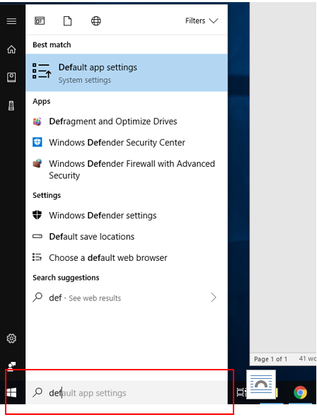

- In the search results, select Default apps. The following Window will display on your screen.

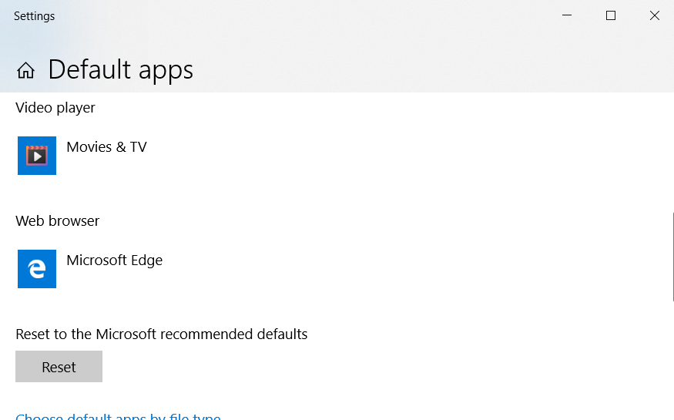

- Scroll down to Web browser and click on the name of the browser currently listed (Microsoft Edge in the example above.) A list of the Browsers on your computer will display as pictured below.
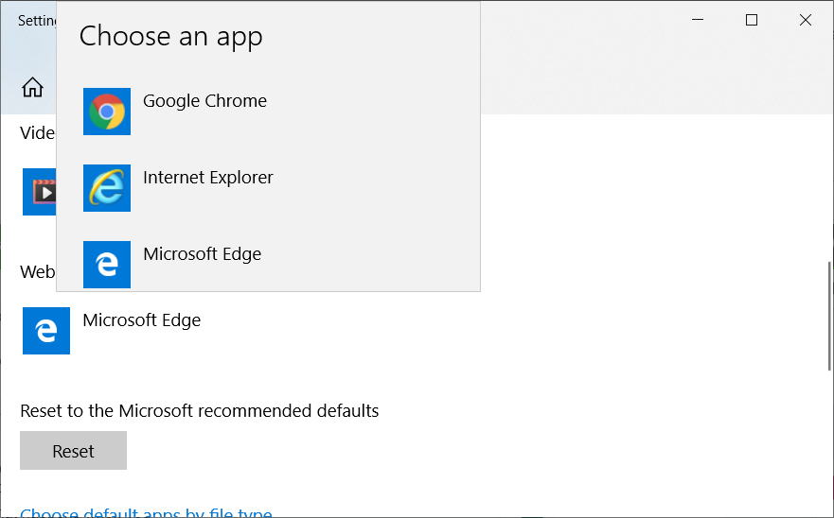
- Select the name of the browser you want as your default browser.
- Close the Window.

- Click the mouse into the Search bar at the bottom of the Windows desktop and then type Default apps.

- In the search results, select Default apps. The following Window will display on your screen.

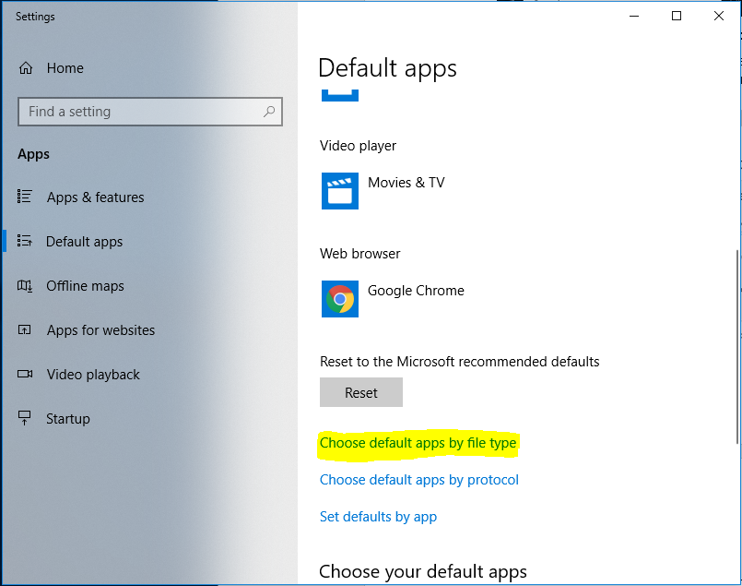

- Scroll down and select Choose Default Apps by File Type. You will experience a brief delay as Windows assembles a list of the File Types on your computer.

- Scroll down to .pdf and click on the name of the application currently listed (Microsoft Edge in the example below) then select Adobe Reader or Adobe Acrobat.

- Close the Window.

