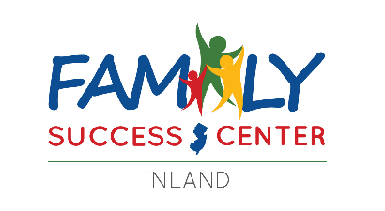

***2025***

**3050 Spruce Ave.**

**Egg Harbor Township, NJ 08234**

**(609) 569-0376 | inlandfsc@gmail.com**

|  |  |  |  |  |  |
| --- | --- | --- | --- | --- | --- |
| ***Monday***  **11:00AM-7:00PM** | ***Tuesday***  **10:00am-5:00pm** | ***Wednesday***  **10:00am-5:00pm** | ***Thursday***  **10:00am-5:00pm** | ***Friday***  **10:00am-4:00pm** | ***Saturday***  **Register on Eventbrite** |
| Local Guides Connect - Disability Pride Month - Local Guides Connect | **1** | **2** | **3** | **4**  **\*Center Closed\***  Happy 4th of July Red Blue SVG | **5** |
| **7**  **No Hit Zone Workshop**  **12-1PM (English)**  **1-2PM (Spanish)**  **\*in-person and virtual\***  **-**  **Summer Paint Night**  **5:30-6:30PM** | **8**  **Shark Week with Parents as Teachers**  **4:00-5:00PM** | **9**  **Employment Café with Atlantic County One-Stop**  **1:00-2:00PM** | **10** | **11**  **Summer Safety for Expecting & New Moms *baby supplies giveaway!\***  **1:00-2:00PM** | **12**  **Build-Your-Own Birdfeeders with Dad**  **10:00-11:00AM** |
| **14** | **15**  **Finding Hope  with TLC**  **1:00-3:00PM** | **16** | **17** | **18** | **19** |
| **21**  **Yoga & Meditation with Tarak**  **6:00-7:00PM** | **22** | **23** | **24**  **DIY Slime Kits**  **\*pick up at center!\***  **11:00AM-3:00PM** | **25** | **26**  **Aguas Frescas at New Day FSC**  **10:00-11:00AM** |
| **28**  **InlandPicnic table** | **29**  **KidsHike** | **30**  **SummerFir tree** | **31**  **Camp! Bonfire** | C:\Users\dalila.martinez\AppData\Local\Microsoft\Windows\INetCache\Content.Word\download.pngimagesC:\Users\johanna.crawford\Downloads\Inland FSC.png  @inlandeht  @inlandfsc  SCAN ME! | |
| **\*This calendar of events can be viewed on our Inland FSC Facebook Page (@inlandeht).\***  **\*All services at Inland FSC such as printing, copying, faxing, and computer lab access are available by appointment only.\*** | | | | | |

***A Program of Center for Family Services Funded Through the County of Atlantic by***

***the New Jersey Department of Children and Families.***

**Shell*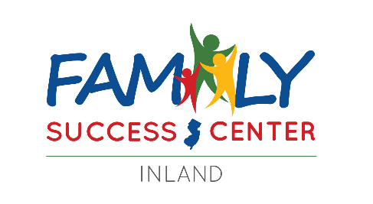July*2025**

**Event Information**

**Schedule an appointment with us!**

**Call 609-569-0376**

**or email us at** [**inlandfsc@gmail.com**](mailto:inlandfsc@gmail.com)

**Monday: 11:00am-7:00pm**

**Tuesday-Thursday: 10:00am-5:00pm**

**Friday: 10:00am-4:00pm**



|  |  |
| --- | --- |
| ***Center Highlights:***  **Summer Safety for Expecting & New Moms**: Join Jean Rose from Connecting NJ for a workshop about protecting your newest addition during the summertime. A light lunch and baby supplies will be provided to those who attend.  **Yoga & Meditation with Tarak**:Our community yogi Tarak will walk us through an authentic yoga routine along with a brief meditation session to find your inner Zen.  **Finding Hope with TLC**:When someone in your life attempts suicide or experiences suicidal thoughts, it can be difficult to know how to best support them in their recovery. Learn about the process of recovery after a suicidal crisis, warning signs to look out for, planning for safety, crisis response, self-care, and more. This workshop is presented by the Traumatic Loss Coalition for Youth.  **Employment Café with Atlantic County One-Stop**: Summer is here! Are you in need of employment? Atlantic County One-Stop Career Center visits Inland once a month to assist you with employment, job searching, resumes, and much more. Enjoy a fresh cup of coffee and chat about the opportunities near you!  **No Hit Zone Workshop**: Join this workshop lead virtually by child psychologist, Dr. Brett Biller to learn more about Practical Strategies for Positive Parenting, Stress Reduction & Support, Boosting Parenting Confidence and more… | ***Family Activities:***  **Summer Paint NightToddler Time: Guinea Pigs**: Happy 4th of July! Celebrate our love for summer as well as our independence with this 4th of July and summer-themed paint night.  **Build-Your-Own Birdfeeders with Dad**: Calling all dads and other father figures! Come out with your loved ones to create an outdoor craft and enjoy birdwatching all summer long.  **DIY Slime Kits**: If your child loves to play with slime, this is the event for you! Sign up for your own slime kit and recreate fun summer slime memories at home with your family.  **Shark Week with PAT**: It’s Shark Week at Inland FSC! Join us and our community partner, Parents as Teachers (PAT) for a shark-themed day of fun, complete with a story and a craft.  **Aguas Frescas at New Day FSC**: Recreate a refreshing summer drink at New Day FSC!  **Inland Kids Summer Camp Grades 4-6**: Get your child involved for the summer at Inland’s Kids Summer Camp! Each day will be filled with fun, enriching games and activities to help build your child’s fundamental life skills. Breakfast, lunch, and snacks will be provided each day. If you are interested and/or have any questions, please feel free to contact us at (609) 569-0376 or via email at [inlandfsc@gmail.com](mailto:inlandfsc@gmail.com). |
| ***Resources:***  **Resources:** Call us at 609-569-0376 or visit us (appointment **only** every Monday-Friday) to get more information on resources in your area!  **Volunteering:** Share your talents with us and your fellow community members! Learn about all the wonderful volunteer opportunities that we have to offer here at our center by emailing us at [inlandfsc@gmail.com](mailto:inlandfsc@gmail.com)! | ***Always Available:***  **Employment Assistance:** Our friendly staff is more than happy to assist you with creating and/or updating your resume, assist with job search, and provide interview advice. Feel free to email us your documents including the type of job you are seeking or the job posting you are interested in. You can email your documents to [inlandfsc@gmail.com.](mailto:inlandfsc@gmail.com.)  **Inland’s Community Club:** We want to hear from you! Register on Eventbrite or give us a call at 609-569-0376 to be a part of Inland FSC’s Community Club.Share your ideas and suggestions with us! |



***Register on***